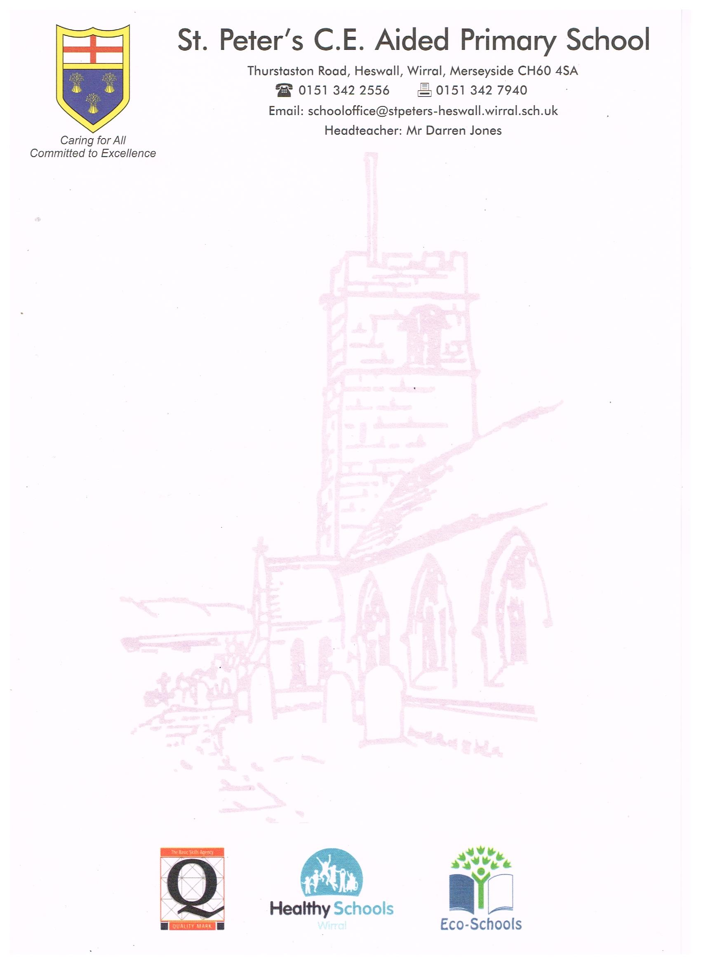
St Peters C of E School
Thurstaston Road
Lower Heswall
Wirral
CH60 4SA
Telephone: 0151 342 9909

ENROLMENT FORM

Child’s Full Name: Date of Birth:

Address:

Post Code:

Telephone Number: Mobile Number:

Email address:

Name of Parent/Guardian:

Church Attended:

Primary School to be requested:

Siblings:

Wraparound care

Wraparound Care is available for children from age 2 years 6 months, in partnership
with Paintbox. This facility is available from 8am till 6pm. For more information please see the relevant page on our website or contact Early years for more information.
Attendance

Start date …………………………………………………………………………………………………………………………

Please indicate your choice of sessions by ticking the appropriate box. We will endeavour to provide parents with their preferred choices, however, if there are insufficient places available you may be offered alternative sessions.

SESSIONS + WRAPAROUND CARE (TERM TIME)
 | BREAKFAST  8am – 8.45am | AM  8.45am–11.45am | LUNCH  11.45am – 12.30pm | PM  12.30pm –3.30pm | AFTER SCHOOL  3.30pm – 6pm
 | Paintbox | St Peter’s CE School Early Years |  |  | Paintbox
Monday
Tuesday
Wednesday
Thursday
Friday

Please complete this form and return it to :- The Early Years Office, St. Peter’s C of E Primary School, Thurstaston Road, Lower Heswall, Wirral CH60 4SA

IF YOU REQUIRE ANY MORE INFORMATION THEN PLEASE DON’T HESITATE TO CONTACT US OR COME AND VISIT TO SEE US IN ACTION.

To be completed by school

Date received:

Date passed to Paintbox:

