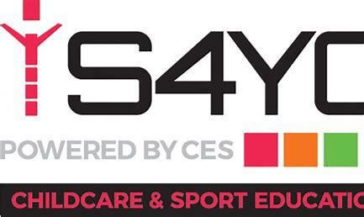

S4YC Breakfast, After School and Holiday Club Booking Information

Dear Parents/Carers,
On-line booking system:
The system we use is called iPAL: http://s4yc.ipalbookings.com this will be the only way parents can register, make bookings and pay for sessions for breakfast, after school and holiday club. If you search on google using the website link above you will be able to create an account and login in and book a club you need and click St Peter’s.
This new way of booking and paying for activities will help you manage, book and pay for your child’s sessional childcare in one secure place.
You will have full access to your account information and invoices via iPAL and will be able to print invoices for tax credit letters, plus much more.
Club prices and times:
- Breakfast Club 7:30am-Start of school £5.03
- After School Club End of School-6:00pm £11.18
- Holiday Club 8:00am-6:00pm £35.00 per day
I would urge all parents to register on iPAL so they have full access to the system and can book and pay for their child or children’s sessions. It is important that you remember your username and password.
For additional support or booking/payment help contact Amy at amy@s4yc.co.uk or Paula at paula@s4yc.co.uk or 07581075534.
Kind Regards,
S4YC
Club Mobile Number- 07951289437 Club email address- stpeters@s4yc.co.uk

