St. Peter’s CE Primary School, Heswall
First Aid and Administration of Medical Emergencies Policy
ST. PETER’S CE PRIMARY SCHOOL
firm foundations, shining bright
John 8:12 “I am the light of the world. Whoever follows me will never walk in darkness, but will have the light of life.”

Matthew 16:18 “You are Peter and upon this rock I shall build my church.”

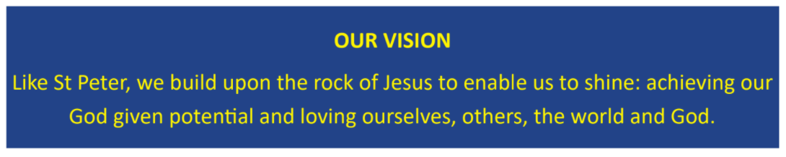
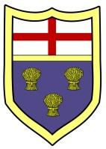

2022 – 2023

First Aid and Illness

The School has registered First Aiders, Paediatric First Aiders and staff who are trained in Emergency First Aid.

Children who feel unwell should be sent to the School Office.

Monitoring of unwell children will be responsibility of the Administrative Staff and the Head Teacher or a member of the Senior Leadership Team (SLT).

The decision to send unwell children home will be solely the responsibility of the Head Teacher or a member of the SLT.

Staff will be made aware of children with Individual Medical Care Plans. In the event of illness, these plans will be followed. A checklist for each class will be kept in the registers for supply staff and other teachers. Full details will be kept in the office and medical records.

A first-aid kit is always taken with a group to any off-site activity. All first-aid equipment can be found in the School Medical Room (ICT Suite). All classrooms have an emergency first aid kit and the school does have access to two defibrillators.

Accident Procedure

For more serious injuries, the injured person will be seen by an adult and referred a registered First Aider, Mrs Jordan, Miss Hughes

If the First Aider believes that hospital treatment is required, that person will, in consultation with the Head Teacher or member of the SLT:

- Arrange for the emergency services (999) to be summonsed if necessary
- Arrange for the parents to be informed
- Arrange for the child/adult to be transported to the Accident and Emergency Department at Arrowe Park Hospital by car taking another adult as the driver
- All accidents will be fully recorded in the Accident Book by the person who dealt initially with the incident
- Parents will be informed by the class teacher, or Head Teacher of significant accidents and the treatment given

At playtimes, a member of classroom staff will deal with minor injuries.

At lunchtimes, the lunchtime staff will deal with minor injuries.

Parents will be informed of any head injury by the child taking home a ‘bumped head’ letter and in most cases a telephone call.

Administration of Medicines

If a child requires medication during the course of the school day, the parent/carer will be asked to complete a Request for School to Administer Medication Form. The medication must be prescribed by a medical professional and have the name of the child clearly marked on it. The medication will be administered by Mrs Moran or Mrs Nash and will either be stored in the fridge in the Staff Room or, in the case of controlled drugs, in the locked cupboard by the School Office.

In the case of Asthma, inhalers are kept in the classrooms by the teacher and are administered by that teacher. Two emergency inhalers are kept in the Head Teacher’s office.

When medication is administered to a child the member who administered the medicine will complete the relevant medical form.

